Unit 1 and 2 Methods

Test 3 Non-Calculator

***Instructions:*** *Show all working clearly, in sufficient detail to allow your answers to be checked and for part marks to be awarded for reasoning. Calculators are NOT are permitted. One page of A4 notes (one side) is permitted.*

Time Allocation: 75 Minutes Total Marks: 69 Marks

**Question 1 [3 marks]**

The graphs of ,  and  are shown below. Determine the values of the constants a, b and c.

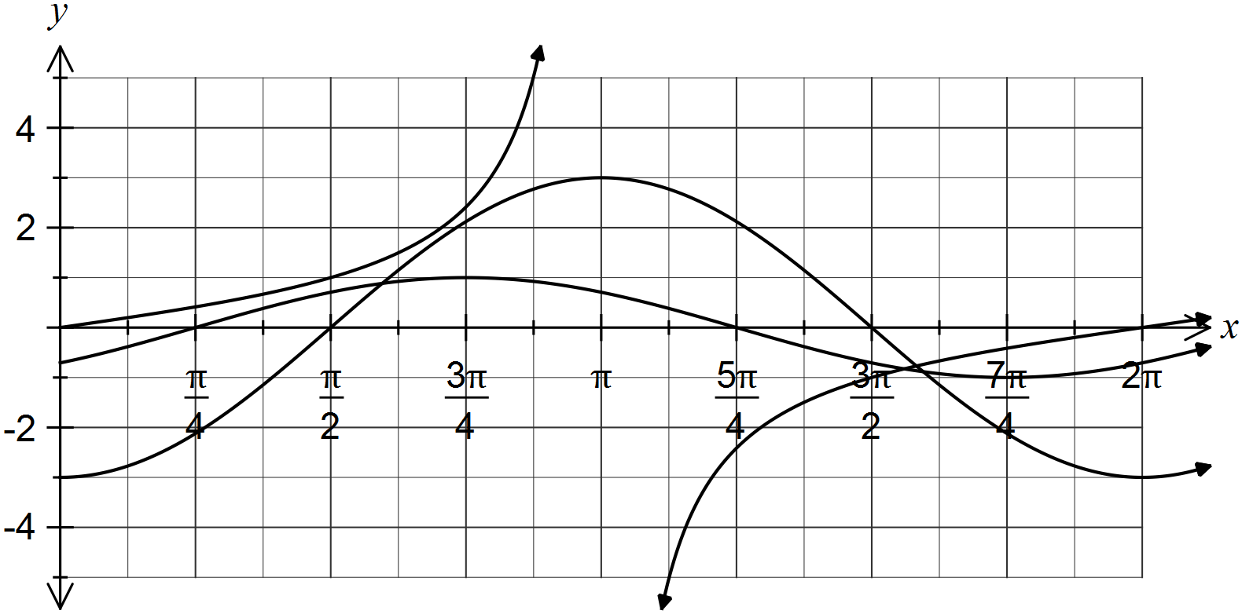

**Question 2 [4 marks]**

If φ and λ are acute angles such that  and , find the exact value of sin (φ + λ).

**Question 3 [4 marks]**

Sketch the following graphs over the domain .

(a) 

(2 marks)

(b) 

(2 marks)



**Question 4 [9 marks]**

Solve for x over the given domain, stating answers as exact values where appropriate.

(a)  

(3 marks)

(b) $2\sin^{2}{x}-3\sin{x}+1=0$ $0≤x<2π$

(3 marks)

(c)  

(3 marks)

**Question 5 [3 marks]**

Find the exact value of cos 75°

(3 marks)

**Question 6 [3 marks]**

For a Universal Set of $\{0,1,2,3,4,5,6,7,8,9\}$, with $A=\{1,3,5,7,9\}$, $B=\{2,4,6,8\}$ and $C=\{2,3,5,7\}$.

List the elements of:

(a) $A∪B$

(1 mark)

(b) $\overline{B}$

(1 mark)

(c) $A∩B∩C$

(1 mark)

**Question 7 [2 marks]**

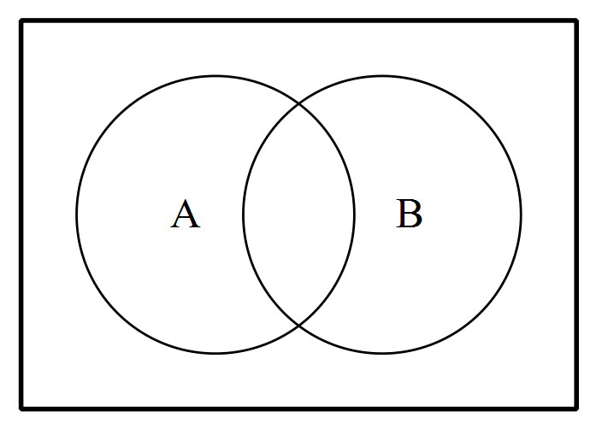Shade the following Venn Diagrams according to the area indicated.

$\overline{A}∩\overline{B}$

(1 mark)

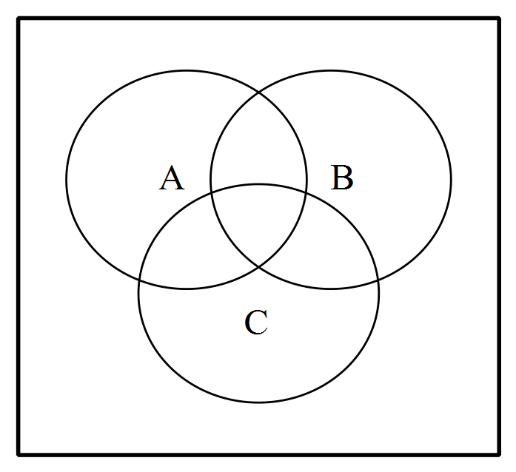

$\overline{A}∩(B∪C)$

(1 mark)

**Question 8 [5 marks]**

Given that . Determine

1.  if,  are mutually exclusive

(1 mark)

(b)  if,  are independent

(1 mark)

(c)  ), if $P\left(A\right| B)=0.2$

(3 marks)

**Question 9 [4 marks]**

A survey of sixty students at a local high school involved preferences for the introduction of a Health Food section into the canteen. The results are summarised in the table below.

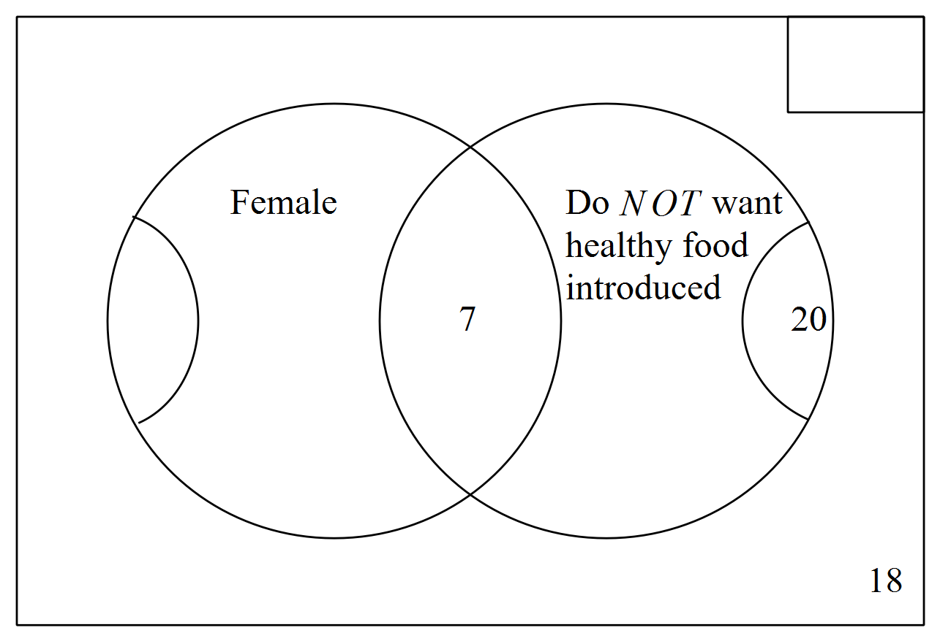

1. Complete the Venn diagram.

(1 mark)

(b) If a student is selected at random from these students, determine the probability that the student:

1. is male and wants the health food introduced.

(1 mark)

(ii) is female or does not want the health food introduce.

(1 mark)

(iii) does not want healthy food introduced, given that he is male.

(1 mark)

**Question 10 [10 marks]**

An analysis of new cars sold recently showed that 80% had automatic transmission (event A) and that 68% were classified as having a small to medium sized engine (event S). It was also noted that 56% of cars had both automatic transmission and a small to medium sized engine.

(a) Use the above information to complete the all the probabilities in this tree diagram.

(5 marks)

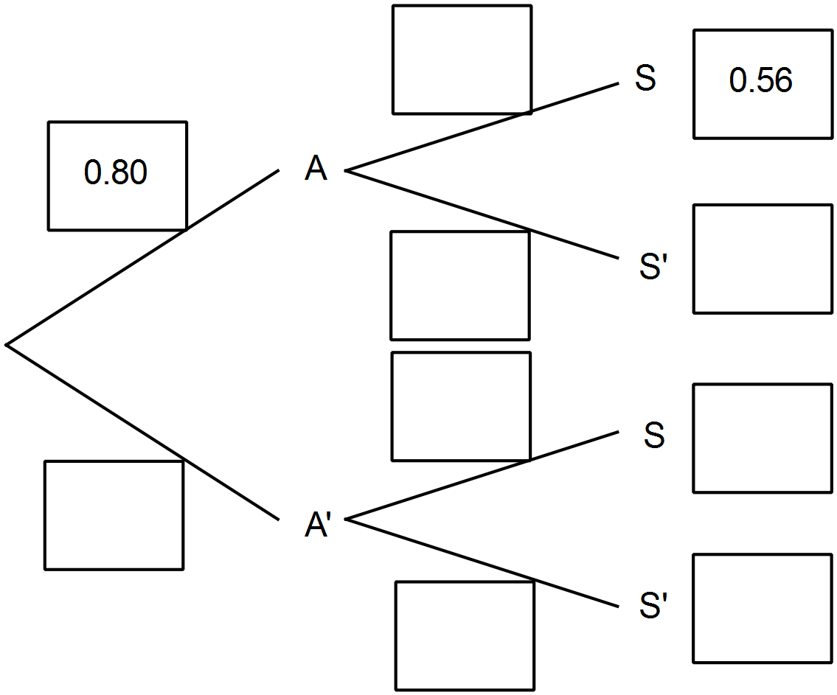

(b) Determine the probability that a randomly selected car will

1. have a small to medium sized engine given that it does not have automatic transmission.

(1 mark)

1. have a small to medium sized engine or have automatic transmission.

(2 mark)

(iii) have automatic transmission given that it has a small to medium sized engine.

(2 marks)

**Question 11 [11 marks]**

Simplify each of the following leaving answers with positive indices:

1. 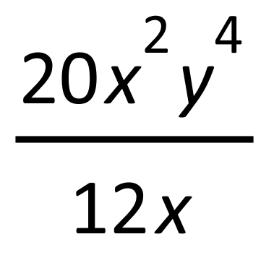

(1 mark)

1. 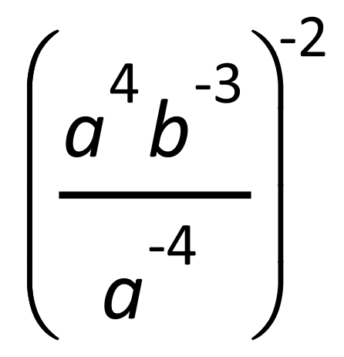

(2 marks)

1. 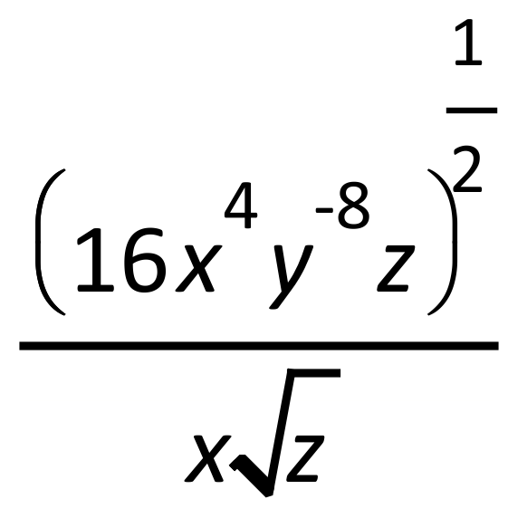

(2 marks)

1. 

(2 marks)



(2 marks)



1. .

(2 marks)

**Question 12 [8 marks]**

Solve the following for :

1. 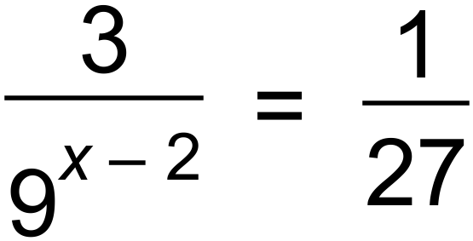

(3 marks)

1. 

(2 marks)

1. 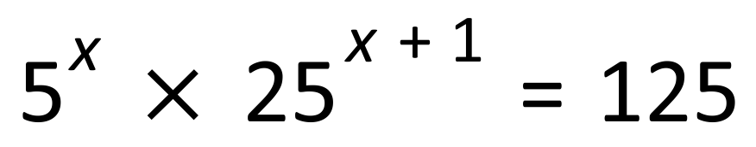

(3 marks)

**Question 13 [3 marks]**

Solve for  in 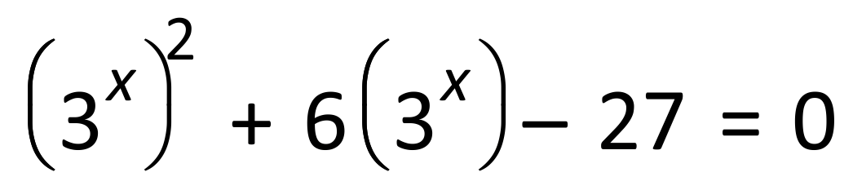 (Hint: Replace 